Pedestrian Crossing Trends
1. Project Overview and Objective
This project involves cleaning, transforming, and analysing raw data using Excel and creating an interactive Power BI dashboard to derive meaningful business insights on the pedestrian crossing data that has been recorded over a period.
The main objective is to demonstrate data pre-processing techniques using Excel and an interactive Power BI dashboard visualization to make informed decisions.

2. Data Sources
- Source Description and Timeline: City of Melbourne / Open Data. Time Line: Previous 2 Weeks
- Domain : Public safety

3. Problem Statement
- To analyse the pedestrian movement patterns over a period
- Understand the footfalls peak and non-peak hours
- Differentiate the drop or increase in pedestrian movement over weekday and weekend
- Help in forecasting the pedestrian movement trend in the future days

4. Attribute (Column /Features) Details:
Attribute Name | Data Type | Description
Location_ID | Integer | Unique identifier for a specific location capturing the pedestrian movement data
Sensing_DateTime | String (Text) | DateTime of the sensing
Sensing_Date | String (Text) | Extracted Date part with type String
Sensing_Time | String (Text) | Extracted Time part with type String
Direction_1 | Integer | No of people moving in 1st direction at the Sensing Date Time
Direction_2 | Integer | No of people moving in 2nd direction at the Sensing Date Time
Total_of_Directions | Integer | Combined no of people moving in either direction at the sensing Date Time
There is also another table containing the details of the Location specified by the Location ID column above

5. Tools & Technologies
- Excel: Data cleaning, transformation, and Pivot Tables.
- Power BI: Data modelling, DAX calculations, visualization, and interactive dashboard creation.

6. Data Pre-Processing (Excel / Power Query)
Tasks Performed:
- Data Cleaning & Transformation: Removed duplicates, handled blank values, standardized formats (Sensing_DateTime field which was text in DateTime format etc), and created calculated fields like Weekday or Weekend into a new column.
- Filtering & Sorting: Organized data by location and datetime to focus on relevant records.
- Pivot Tables: Generated Pivot Tables for data summarisation and initial insights.

7. Data Modelling and DAX (Power BI)
- Data Model: Established relationships between tables, defined cardinality, and created lookup tables where necessary.
- Calculated Columns & DAX Measures: Implemented DAX formulas for key metrics, such as: Average Pedestrian Count, Average Pedestrian Count, Peak Time on Weekends etc

8. Analysis and Visualizations (Power BI)
Dashboard Features:
- Multiple Visualizations based on problem statement: Bar charts, line charts, pie charts, cards, and tables to communicate insights.
Bar charts for Average Pedestrian Count Per Day, Sum of Total_of_directions and Average Pedestrian Count Per Day, Pie Chart for Sum of Total_of_Directions, Measure Chart of Sum of Pedestrians and Average of Pedestrains on weekday and weekend
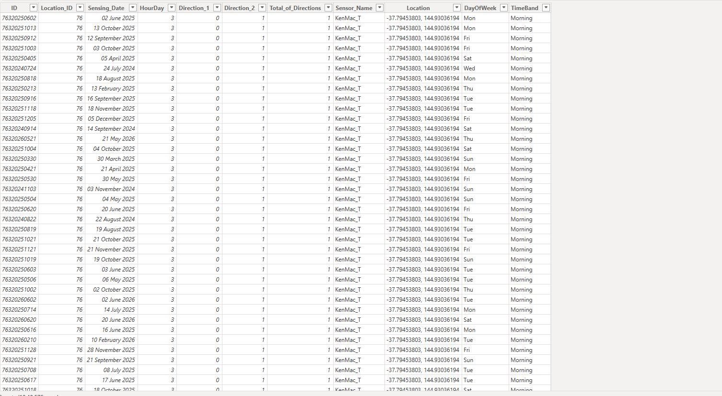

9. Insights & Conclusions
Key Findings: The analysis shows that Melbourne CBD pedestrian movement is strongly concentrated around the Swanston Street–Town Hall corridor, with clear peak periods during lunchtime and the evening commute.
- Overall recovery and growth: Melbourne CBD recorded 192.4 million pedestrian movements across 102 sensor locations from June 2024 to June 2026. The 2025 total reached 98.3 million counts, and 2026 is tracking at a similar annualised level, indicating that CBD foot traffic has recovered strongly and stabilised at a high volume.
- Evening commute is the dominant daily peak: The 5 PM period is the busiest system-wide hour and appears as the peak hour for most of the highest-volume locations, making the 4–6 PM window critical for transport planning, event coordination, public safety, and crowd management.
- Lunchtime is a major secondary peak: The 12 PM to 1 PM period generates almost as much activity as the evening rush, showing that office workers, students, retail visitors, and hospitality customers create a strong midday economy.
- Friday and Saturday drive the strongest weekly activity: Friday is the busiest day, closely followed by Saturday. This suggests that normal commuter movement combines with retail, hospitality, and leisure activity toward the end of the week.
- Seasonal peaks occur in March and October: These months consistently deliver the highest pedestrian counts, likely influenced by favourable weather, major city events, festivals, retail activity, and full business or education schedules.
- Town Hall and Swanston Street form the busiest pedestrian spine: Town Hall (West), Flinders Lane–Swanston Street, QV2 Apartments, Elizabeth Street–Flinders Street, and Melbourne Central are among the strongest locations, proving that pedestrian flow is highly concentrated in the central retail, transport, and civic corridor.
- Planning implication: Infrastructure upgrades, event scheduling, retail staffing, and safety measures should prioritise the busiest corridors and the highest-impact time windows, especially lunchtime and the evening commute.
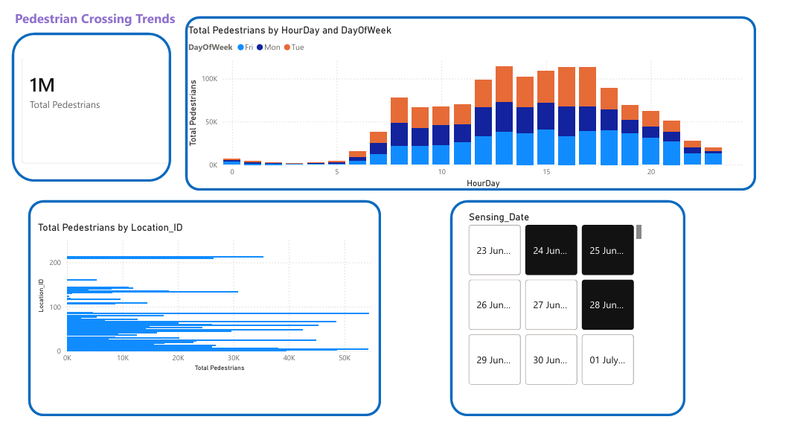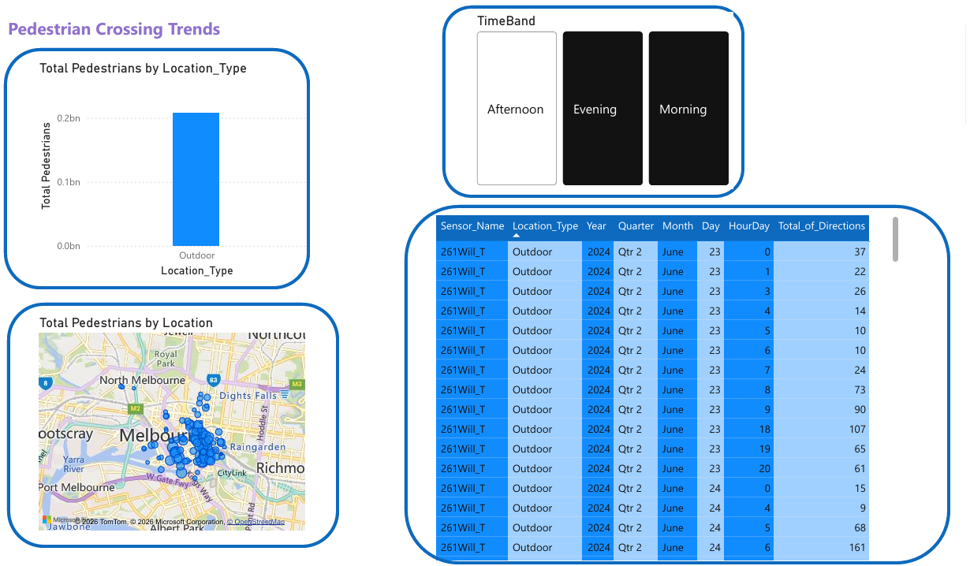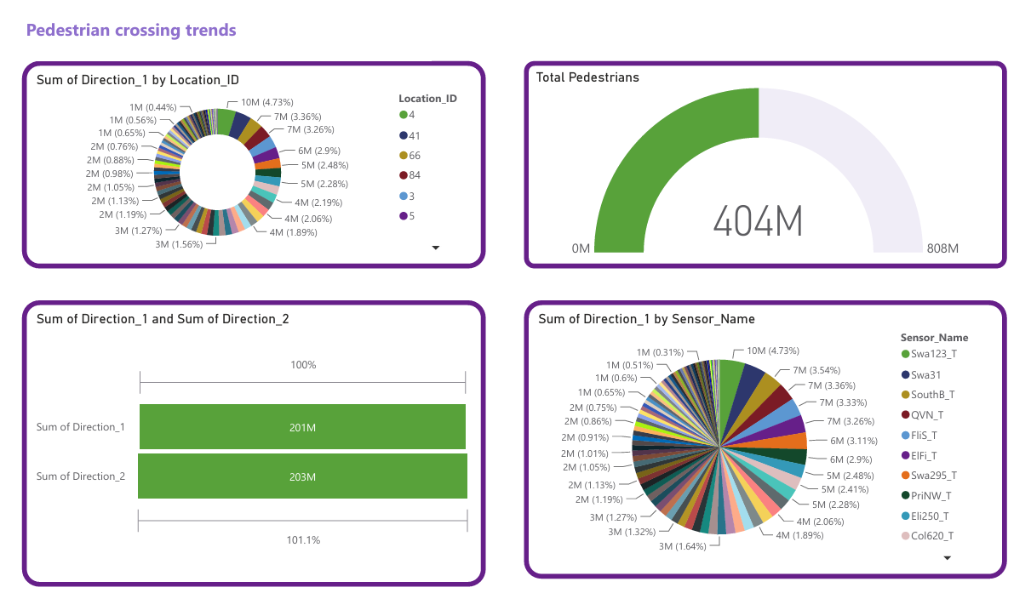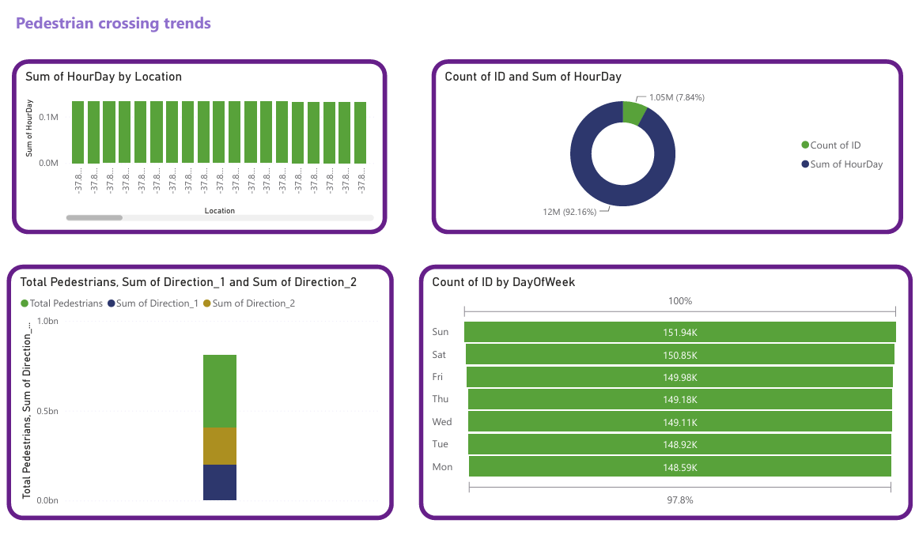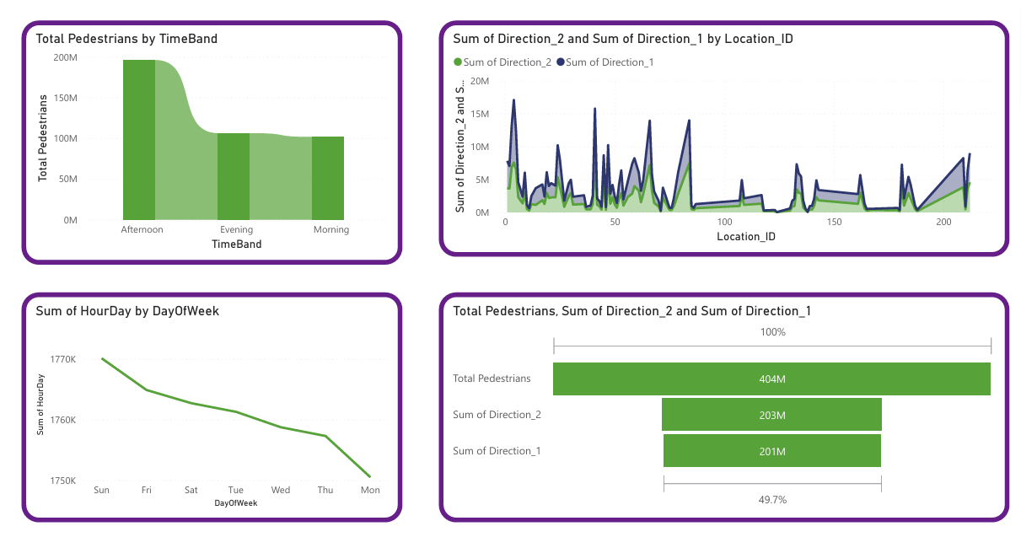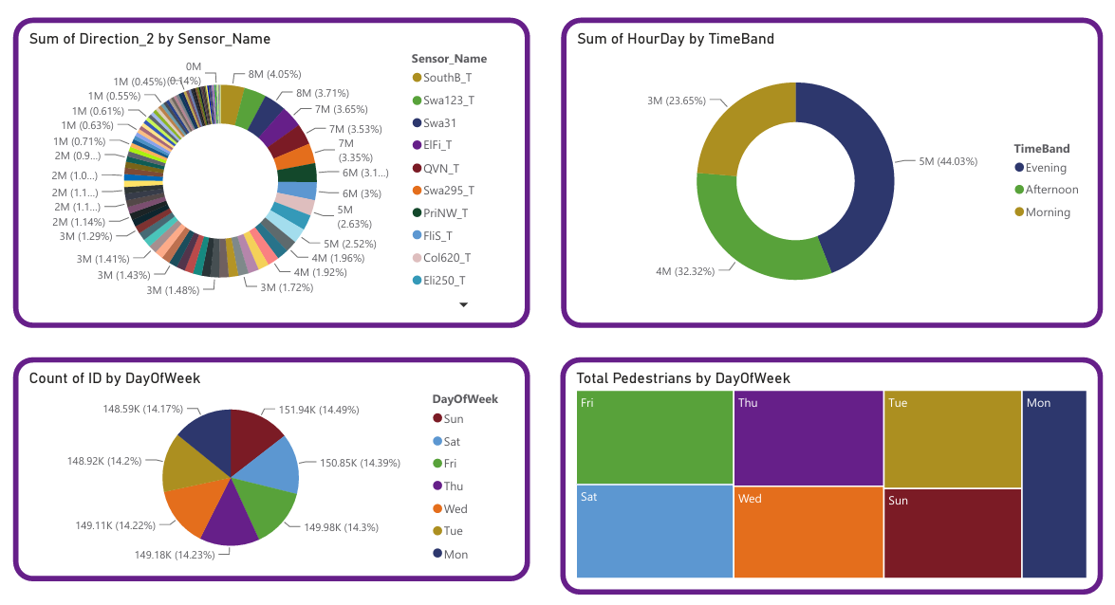

10. Conclusions
The analysis confirms that Melbourne CBD has a resilient and highly active pedestrian network, with sustained recovery in foot traffic and strong recurring patterns across time, day, season, and location. The evening commute remains the most important daily movement period, while lunchtime represents a significant commercial and planning opportunity. The Town Hall–Swanston Street corridor should be treated as a critical pedestrian zone because of its high concentration of movement. Overall, the Excel and Power BI workflow successfully transformed raw pedestrian-counting data into practical insights that can support urban planning, public safety, event management, retail operations, and future pedestrian trend forecasting.

